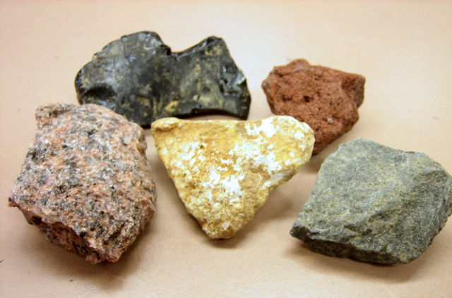

Compare: If a question asks you to ‘compare’ one thing with another then you are being asked to show how the two things are similar and also how they are different. In your answer you need to include at least one similarity and at least one difference.

1. Write some things that you know about igneous rocks _____________
____________________________________________________________________________________________________________________________________________________________________________________________________________________________________________________

2. Write some things that you know about sedimentary rocks _________
____________________________________________________________________________________________________________________________________________________________________________________________________________________________________________________

3. Now compare the two. ______________________________________
_________________________________________________________________________________________________________________________________________________________________________________________________________________________________________________________________________________________________________________
__________________________________________________________________________________________________________________________

________________________________________________________________________________________



